Subject: Programming with Java
ASSIGNMENT No : 12
TITLE :Write a Java program to create and use user-defined packages.

Problem Statement
Write a Java program to create and use user-defined packages.
Learning Objectives
To create and use user-defined packages for organizing Java programs.
Theory
Packages are used to organize related classes and interfaces into namespaces. User-defined packages improve code organization, reduce naming conflicts, and enhance reusability. They also support access protection and modular application development. Java packages simplify project management by grouping logically related components together. Large-scale software systems extensively use packages.
Outcome
After completing this experiment, we learned how to create and use user-defined packages in Java. We understood how packages help organize related classes, improve code reusability, and avoid naming conflicts. The experiment enhanced our understanding of modular programming and package importing in Java.
Conclusion
The experiment successfully demonstrated the creation and use of user-defined packages in Java. It showed how packages group related classes into logical units, making programs more organized, reusable, and easier to maintain. User-defined packages are an important feature of Java for developing modular and well-structured applications.

Exercise
Q1.Create a Java program by developing user-defined packages for a College Management System. Create separate packages for student and faculty details, and display their information using classes from these packages.
->
Code:
Student Package:
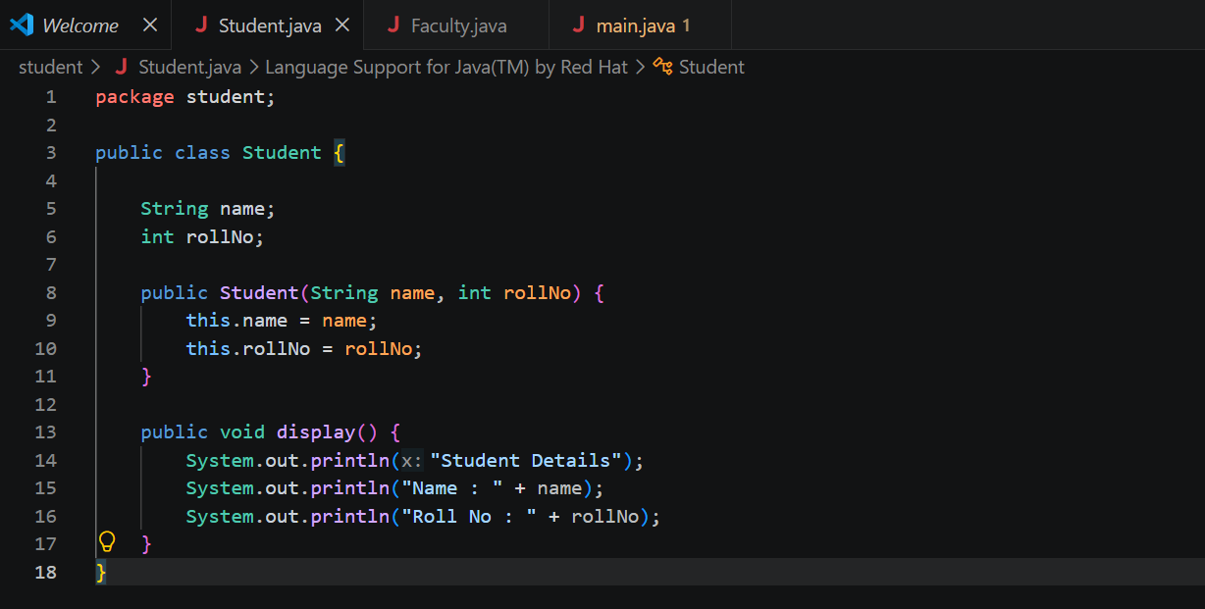

Faculty Package:
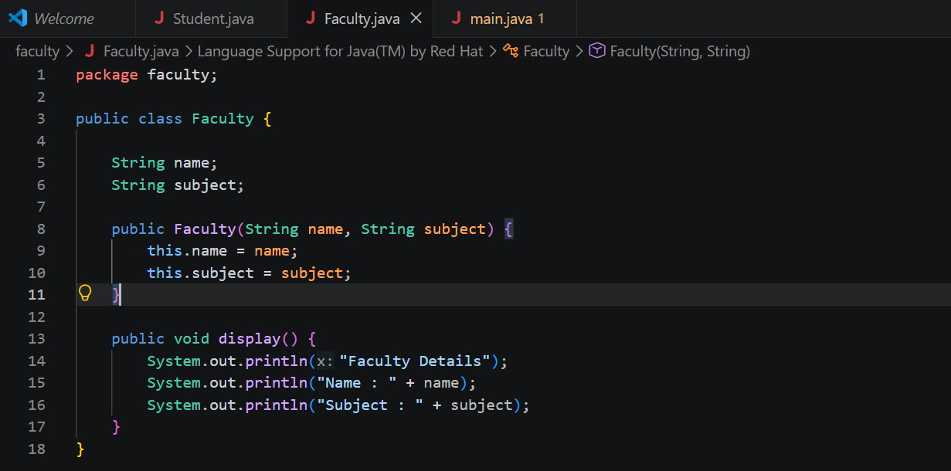

Main:
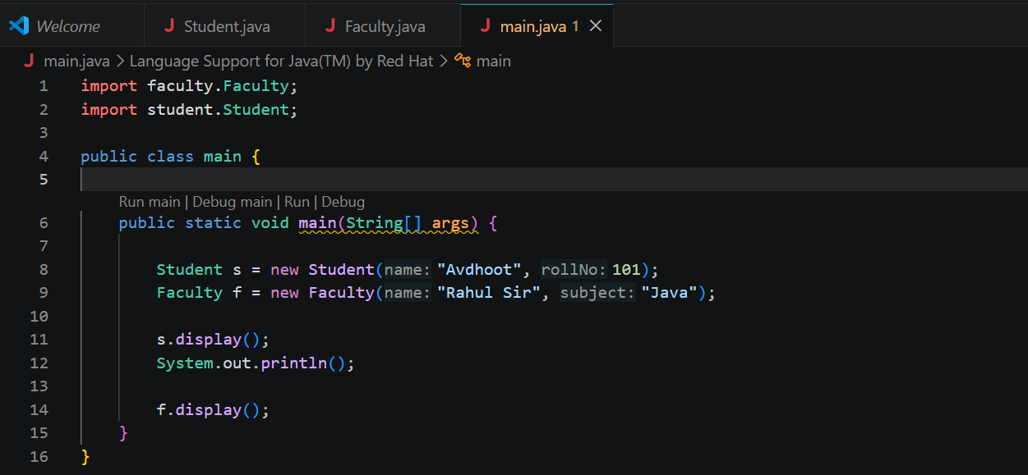

Output:
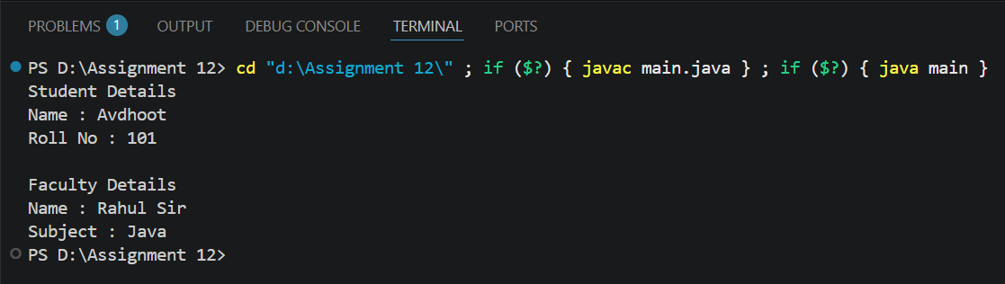

Q2 Create a Java program by developing a user-defined package named library that contains a class to store and display book details such as book ID, title, author, and price. Import the package into the main program and display the book information.
->
Code:
Book package:
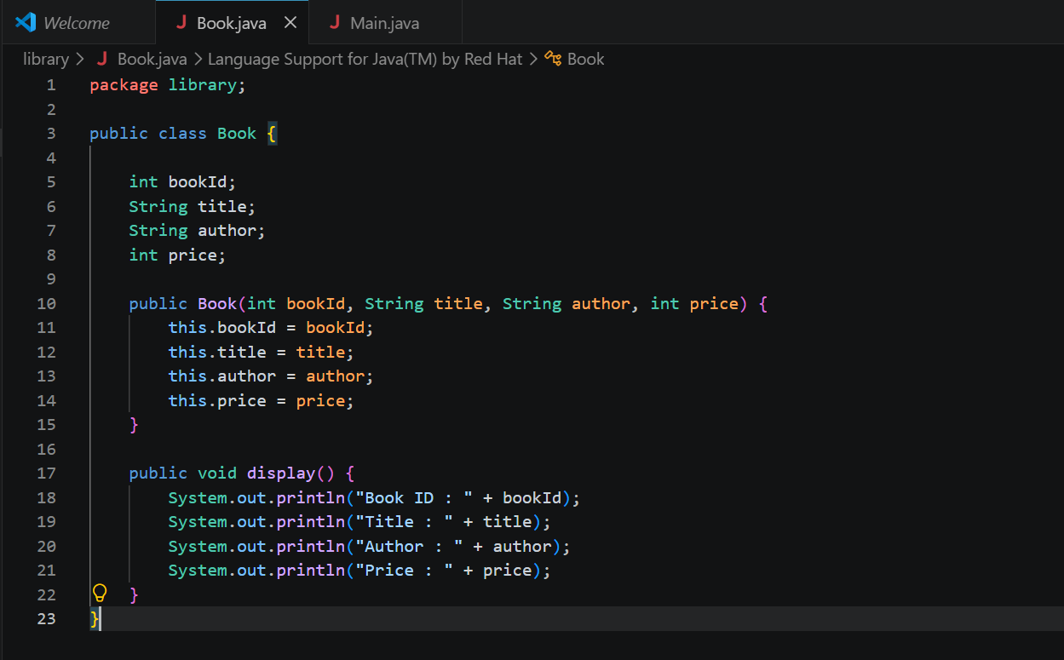
Main:
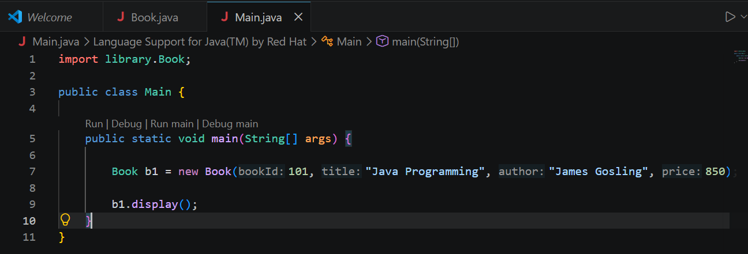
Output:
